The Hidden Power of Authentic Love in the Family & Interpretation of Dreams
January 17, 2017
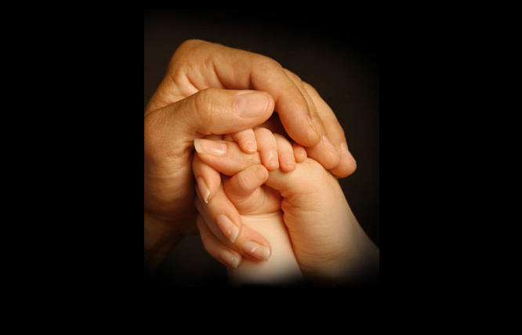
Let us pray that the Lord will grant us love, patience and courage as we live our day to day lives in our families and that we will fulfill His will for us as husbands, wives and parents.

I asked the Lord what He wanted to talk to me about tonight, and He said:

“Love. There is no better remedy for all your ills and all the ills of mankind than love that has no conditions and bears with contradictions, misunderstandings, disputes, and sins of all kinds. It is still love that is the antidote.

"Many of you have learned through example and experience that Love is the fail-safe way to handle all situations that are headed for disaster. Love is patient, love is kind, love does not show off nor arrogantly defend its position. Love never fails. It never fails to hope and eventually, though you see it not, I bring all things back around to love. The only exception is for those who have chosen to hate and want nothing to do with Me or with Love.

"Those are the lost souls, who could not bring themselves to agree with anything heavenly. They had to stand against all that did not serve to enlarge their bitterness and hatred. These souls can be made to comply on the outside, but at the first opportunity, hatred and bitterness will out and they will oppose all that is good, healing and forgiving.

"This is why I have told you, 'Don’t let the sun go down on your wrath.' Because if you allow those seeds to send roots into the soil of your heart, by morning you will be fighting not just thoughts or seeds, but strongholds. Yet there are times when you sleep that I take you aside and bring healing and in the morning's first light you are anxious to make amends in the situation that before had caused you bitterness. This is My supernatural help for My Beautiful Bride when she is deeply wounded.

"In fact. I do much with your souls at night. Sometimes your dreams will reflect what we did together with family members and you will awake with a fresh perspective on their prayer needs. Clare, the dream you had this morning was one of those times. There is a soul crying out for your intercession. Do not neglect this."

Oh, thank you Lord, for confirming it.

"So many times your intellect has already given up on an area of your family that is far from hopeless. I bring you dreams and experiences in the spirit with them in order to resurrect those feelings you once had between you. I know you do not want to look at the failures of the past, but remember that, while you are growing, so are they - and they need your prayers.

"The substance of your dreams, My Bride, has to do with your spiritual work. I’m not talking about senseless dreams or nightmares, but those epic dreams you have that reflect an area of your consciousness that you are involved with the world in. Sometimes they are prophetic; sometimes they are from lying demons. It is up to you to discern the source. The signature of the Holy Spirit is always peace. A peace that transcends understanding, a clarity and understanding that brings peace.

"Many try to compartmentalize symbolism in their dreams. It’s not that easy. I speak to each individual on the levels of their own understanding and familiarity, rather than in a set pattern. There are a few exceptions to the rule, but I ask you not to assume that a symbol means to you what it means to others. Again, I am speaking with you and giving you insight - and each symbol I use has a history behind it that only you understand.

"Now an exception to that is prophetic dreams that have to do with the world. In which case, many symbols are common across the prophetic sphere and it's safe to assume that certain symbols in your dream have prophetic meaning that recurs throughout history.

"Always ask My Holy Spirit to give you insight into your dreams. Bring them before Me in your dwelling prayer and lay them at My feet to provide you with the necessary insight.

"Beware of dreams that cause you to be angry, resentful, jealous or judgmental. These are from the enemy. My Spirit is one of peace and understanding, never fear or condemnation, although I will warn you in dreams not to get involved with certain people and situations. Visitation dreams are very, very special, because they are so real."

And I'd just like to say here, that a visitation would be a dream where you had an experience with Holy Spirit or God the Father or Jesus. Or Elijah or one of the prophets. Very, very special. And something definitely worth remembering and making a memorial for.

"My People, build an altar there when you have a dream that is a special grace. What I mean by building an altar is to make a memorial stone, whether it be an entry in your journal with Rhema cards that you will use at a future time, or an object reminding you of the dream. I will very often confirm dreams, messages and thoughts with an object in the physical world. It may be a heart-shaped fruit, a smear of butter, the way an egg cooks or one of your animals insisting that you allow them to groom you."

I love those kinds of confirmations!

"I very often use your animals and things in nature to get your attention. Cloud formations, rocks that cry out with a message in their shape, birds, flowers blooming out of season - oh, so many many ways I try to get your attention. If you see something that edifies you and confirms a thought or direction, you are wise to assume it is My sign to you. Take a photo of it and keep it in your journal. That is an altar honoring My promises to you."

And what I've noticed about that is, when my faith wavers or I'm under attack, I go back in my journals and I look at those altar stones, so to speak. It give me strength and courage and reminds me that the Lord is faithful.

He continued, "I speak to you in many ways during your day. You perceive less than half of them. Especially when it is something you’d rather not hear. But understand, My dear ones, I am trying to divert you from things that are not healthy and will cause pain.

"At such times, it is always best to sit quietly with Me and give Me your full attention, wait until My presence becomes clearer. Then listen, very carefully. I do not stop you in your tracks for no reason at all, there is always a reason. Your corresponding to My invitation to listen will bring you into the sweetest kind of intimacy with Me and save you many painful losses.

"But as I began this message with love I want to close with love. Right now many of you are in conflict with your families and spouses. I have never called you to be so holy that you are unapproachable or indifferent to their needs. Go out of your way to meet the desires of your spouses and children. If you spurn their needs because of your relationship with Me, you will cause them to resent Me in your life, and drive them further away.

"I’m not talking about sin; never give in to any sin. Stand against it with gentle resolve, never harsh condemnation or judgement.

"I’m talking about the innocent things your husband and children need you to be present for. You are a light shining in the darkness. You bring Me with you everywhere you go and My presence should bring joy, peace and brotherly love. But if you are harboring resentment for the time you must give them, you will not reflect those things. Rather there will be an underlying tension and a sense that you’re really not there for them, that other things are more important.

"May I say, nothing is more important in a marriage than making your family and especially your spouse feel loved and honored without any trace of resentment hiding in your heart or thoughts?"

And here I know from previous lessons from the Lord that He's not excluding prayer and proper conversation. For instance, no gossip or judging between the two of you. Those are super poisonous things that will destroy a marriage, because it opens so many doors. But He's also talked about, of course, the importance in prayer and putting Him first in your heart, your mind and your life. What He's talking about here is the allowance He wants you to make for your family. Even though, sometimes you want to be in prayer. Sometimes it's more judicious and it's better to take care of the needs of your family, and it'll go farther towards their conversion than if you lock yourself up and remain remote.

Jesus continued, "Nothing turns a man off to ‘religion’ as fast as a self-righteous, super-spiritual wife. It is degrading and belittling to him and rather than compete with you to be holy, he will run the other way. Rather you should be engaging him and honoring the place I have given him in your life. Many times I will speak truth and correct direction through an unbelieving spouse. Why? Because I honor and confirm his authority in the family. That does not mean that you are bound to indulge in sin, their are delicate ways to back away from anything that troubles your conscience.

"Yet you must learn the difference between a spirit of religion or religious spirit, and My tender Spirit leading you to do things that will endear you to him and build him up. It is not easy to build up a man who is not pursuing Me with his whole heart. But part of what I created you to do is to make him feel capable of hearing from Me by honoring him, and complementing him when he turns to Me.

"This is why I exhort you to do everything from a spirit of love. Many have ruined their marriages beyond repair by being super-spiritual and doing all kinds of ‘big’ things for Me, when all I wanted was for them to love their families as an example of how I love them. When they feel loved and honored they are drawn to Me because you, indeed, are flowing freely from rivers of living waters which I have cleansed and nourished you with.

"They will desire the headwaters of this river because it is Love. And Love does its work silently in the soul until they are tired of the world and its rewards, at which point they hunger for authentic love. Be that love to them, My Beautiful spouse. Be that love to them and never, ever make them feel little or insufficient before Me.”

